

**VIDEO ANALYTICS**

**(CSE3043)**

J Component – Project Report

**PARKING SLOT DETECTION USING DEEP LEARNING**

*By*

Mandla Sheshi Kiran Reddy – 20BAI1061

Amaravadi Dheeraj - 20BAI1061

Uppanapalli Lakshmi Sowjanya - 20bai1289

B.Tech CSE

*Submitted to*

**Dr. Maheshwari S,**

Assistant Professor Senior,

SCOPE, VIT Chennai

School of Computer Science and Engineering

April 2023

|  |  |  |  |
| --- | --- | --- | --- |
| **SI No.** | **CONTENT** | | **PAGE No.** |
| 1. | **ACKNOWLEDGMENT** | | 3 |
| 2**.** | **ABSTRACT** | | 4 |
| 3. | **INTRODUCTION** | | 4 |
|  | 3.1  3.2  3.3  3.4  3.5  3.6 | Why AI is needed for this project?  PEAS Description  Environment type  Architecture type  Existing system  Proposed methodology | 5  5  5  5  5  6 |
|  | **LITERATURE SURVEY** | | 6 |
| 5. | **ARCHITECTURE DIAGRAM** | | 9 |
| 6. | **MODULES** | | 10 |
| 7. | **TECHNOLOGIES AND INTEGRATION** | | 15 |
| 8. | **IMPLEMENTATION DETAILS (SOFTWARES USED)** | | 16 |
| 9. | **RESULTS AND DISCUSSIONS** | | 17 |
| 10. | **CONCLUSION AND FUTUREENHANCEMENTS** | | 17 |
| 11. | **REFERENCES** | | 18 |
| 12. | **SAMPLE CODE** | | 18 |

**ACKNOWLEDGMENT**

The success and final outcome of this assignment required a lot of guidance and assistance from many people and we are extremely fortunate to have got this all along with the completion of our project. Whatever we have done is only due to such guidance and assistance by our faculty, DR. MAHESHWARI S, to whom we are really thankful for giving us an opportunity to do this project.

Last but not the least, we are grateful to all our fellow classmates and our friends for the suggestions and support given to us throughout the completion of our project.

**ABSTRACT**

Finding a suitable parking space in a populated metropolis is very difficult for a driver. In the absence of a parking space, serious traffic jams can occur. Automated intelligent parking system is an emerging field and has attracted computer vision researchers to participate in this technological arena. In this paper, we presented a vision-based intelligent parking framework that helps the driver efficiently find and reserve suitable parking spaces. At first, we segmented the parking lot into blocks by calibration. Then classify each block to identify cars and determine the driving force behind the parking status, whether reserved or free. The performance accuracy of the proposed system is potentially higher than that of state-of-the-art hardware solutions, which confirms the superiority of the proposed framework.

**INTRODUCTION**

The automatic parking space detection system tells us how many free spaces we have and how many spaces we have in total in the parking lot. We colored the free space with green and the full space with red. When the car leaves, the card slot is automatically green when empty. We are trying to use image processing techniques in our project.

Our system helps the real world and people using image processing techniques and machine learning. Parking is a big problem everywhere because people drive big vehicles and enjoy themselves, but spend a lot of time in the parking lot because there is a lack of space. So this system helps the male friend not to waste most of his time looking for a parking space. It is a customer service system, because it is not really a working robot, but if the results sent by it can be turned into a chat or some other system that tells you free space and assigns a parking space. This can be used as future research. Using Python image processing modules and other modules to help and understand parking spaces. Understand how all other systems work with parking lots. The best way to find and solve the problem of parking spaces.

**3.1 Why AI is needed for this project?**

Our system can't just predict like normal other models because others only predict based on quantity and filled position. But because the system should understand in which position the parking is and where the parking can be, and AI is also needed to control the vehicle.

This helps our system to think like a human because we think that we only need to park in the available space at our parking coordinates and we can park in any available space. So AI is very necessary for our project.

**3.2 PEAS Description**

* Performance measurement: Checks whether the vehicle is parked or not. •
* Environment: parking lots with specific parking lots.
* Actuators: display screen or monitor (the parking positions of the car and free slot position).
* Sensors: cameras.

**3.3Environment type**

* Fully observable: Our system will observe the complete parking slot location and the keeps a track on each parking slot.
* Deterministic: the system easily finds the next step of the agent because it understands that if there is no car in one place, then parking is done. If there is a car in one place, it means that the car will leave after some time. But checking whether the car exists or not is difficult.
* Sequential: The system can say the next action according to its previous action.
* Static environment: The environment should not change in any cost because of the measurements of the parking slots.
* Discrete: The system will know all the actions that should be performed.
* Multi-agents: There will so many vehicles and so many drivers.

**3.4 Architecture type**

* OpenCV is the tool used to process all images and videos. it is a huge open source library for computer vision, image processing and other purposes.
* CVzone is a computer vision package that facilitates us, such as face recognition, hand tracking, pose estimation, etc., as well as image processing and other artificial intelligence functions.

**3.5Existing system**

* Existing systems are mostly featured just to find a parking space, but the system was not accurate enough to check if there are obstacles in the spaces.
* All systems only tried to find out if a slot was free or half section free, but not if it was filled with any object or vehicle.
* If the vehicle is parked completely towards the corners and blocks the interface or some object covers the partition, the system will mix the 2 parking spaces into one and the coverings will be incorrectly predicted.
* However, our system determines the coordinates and controls the execution, which helps the system to predict.

**3.6 Proposed Methodology**

* It is difficult for the system to recognize the parking space by the normal method (example: white or yellow lines) because there can be problems in detection because anyone can park on that line and anyone can stand, so no system work properly.
* A professional will recognize our system. He inputs information, such as selecting blocks for a parking space, and this can help the system analyze exactly that location and eliminate all other locations.

**LITERATURE SURVEY**

**PAPER - 01:**

# Automatic free parking space detection by using motion stereo-based 3D reconstruction.

**Link:**

<https://link.springer.com/article/10.1007/s00138-008-0156-9>

**Intent :**

This paper proposes a free parking space detection system using motion stereo based 3D reconstruction. The image series is acquired with a single inversion fisheye camera, and the view from behind the car is reconstructed three-dimensionally using point correspondences. Metric data is obtained from the height ratio of the camera, and free parking spaces are detected by estimating the location of adjacent vehicles. Since side-by-side vehicles are usually located near the epipole, their structures are highly degraded. To solve this problem, we select point correspondences using a derotation-based method and mosaic 3D structures by evaluating a similarity transformation. Unlike previous works, our system offers an efficient way to find available parking spaces in a 3D point cloud. An odometer is not used because its accuracy is highly dependent on road conditions. In the experiments, the system was tested in 154 different parking situations and its success rate was 90% (139 successes in 154 cases). Perceptual accuracy was evaluated using ground-truth data acquired with a laser scanner.

**Outcome :**

In this paper, a motion stereo-based 3D reconstruction-based free parking spot identification system is proposed. A single rearview fisheye camera is used to capture an image series, and point correspondences are then used to recreate the picture in three dimensions. Free parking spaces are discovered by calculating the positions of nearby vehicles and metric information is recovered from the camera height ratio. Due to their regular proximity to the epipole, nearby vehicles' structures suffer severe degradation. We use a de-rotation-based method to choose point correspondences for this challenge, and we estimate a similarity transformation to choose mosaic 3D structures. Unlike earlier work, our algorithm suggests a practical method for finding unoccupied parking spaces in 3D point clouds. Odometry is not employed because of how heavily the accuracy depends on the state of the roads. The system was tested in the experiments in 154 distinct parking scenarios, and its success rate was 90%. (139 successes in 154 cases). Utilizing ground truth data that was collected using a laser scanner, the detection accuracy was assessed.

**PAPER - 02:**

OpenCV for Computer Vision Applications

**Link:**

<https://www.researchgate.net/publication/301590571_OpenCV_for_Computer_Vision_Applications>

**Intent:**

The purpose of image processing is to help a computer understand the content of an image. OpenCV is a library of software functions mainly used for image processing. It provides a de facto standard API for computer vision applications. With the help of image editing applications, we can solve many real-time problems. This article covers OpenCV real-time imaging applications and steps.

**Outcome:**

OpenCV's primary user interface is written in C. Python, Java, and MATLAB now have full interfaces. Other languages such as C#, Perl and Ruby have developed wrappers. A CUDA-based GPU interface has been in operation since 2010. OpenCV has been supported by Intel and the recently privately funded new robotics research center Willow garage. openCV can run on different platforms such as Windows, Android, Blackberry, openBSD, ios and Linux. Research is underway to implement new modules in openCV to support robot perception.

**PAPER - 03:**

Intelligent Parking Space Detection System Based on Image Processing

**Link:**

<http://www.ijimt.org/papers/228-G0038.pdf>

**Intent:**

The purpose of this paper is to introduce an intelligent System identify the parking lot based on image processing

a technique that captures and processes a brown circle image

is designed in the parking lot and produces data empty parking lots. It will appear on the screen consists of seven segments in real time. Sept the segment display shows the amount of current available parking spaces in the parking lot. This proposed system is developed on a software and hardware platform.

Index terms: smart parking, parking lot detection, graphics.

**Outcome:**

The intelligent parking spot detection system is based on

image processing was developed and tested. Identifying

a round brown image drawn on each parking space a

Reference to image recognition, it changes the process

identifying an image as a reference more effectively than using a moving object. Conceptualizing it. The goal of the project is to find a parking system using an image processing instead of using a sensor base. Intelligent parking

the system is developed with integrated image processing

approach reduces sensor and wiring costs. The future

the study focuses on the secure parking system a completes this intelligent parking space recognition. Other controls, such as light control free parking space and the placement of LED lights in each parking space is also considered.

**PAPER - 04:**

Automatic Parking Space Detection System

**Link:**

[https://www.researchgate.net/publication/320736588_Automatic_Parking_Space_Detection_System#:~:text=In%20this%20paper%2C%20a%20system,the%20images%20of%20the%20parking](https://www.researchgate.net/publication/320736588_Automatic_Parking_Space_Detection_System)

**Intent:**

Finding a suitable parking space in a populated metropolitan area is very difficult for drivers. In the absence of a parking space, serious traffic jams can occur. Automated intelligent parking system is an emerging field and it has attracted computer vision researchers to participate in this technological arena. In this paper, we introduced a vision-based intelligent parking framework that helps drivers efficiently find and reserve a suitable parking space. Initially, we segmented the parking lot into blocks using calibration. Then classify each block to identify the car and tell the driver the parking status, whether reserved or free. It is possible that the performance accuracy of the proposed system is higher than state-of-the-art hardware solutions, which confirms the superiority of the proposed framework.

Keywords - intelligent parking management; automatic parking; identification of nests; parking lot detection; machine learning

**Outcome:**

The main contribution of this study is to optimize the detection of available parking spaces to potentially reduce congestion in the parking arena. Thanks to advances in machine learning and vision-based technology, cost-effective automated parking systems help drivers find available parking spaces. Future researchers can focus on assigning a specific location to customers already registered by the online parking system.

**PAPER - 05:**

A Smart Image Processing-based System for Parking Space Vacancy Management

**Link:**

<https://www.researchgate.net/publication/326439400_A_Smart_Image_Processing-based_System_for_Parking_Space_Vacancy_> Management#:~:text=An%20image%20processing%20algorithm%20is,spots%20are%20occupied%20or%20otherwise

**Intent:**

Drivers often have problems finding empty parking spaces in parking lots. This paper presents an intelligent parking management system that works with image processing. Empty parking spaces are identified from aerial images of the parking lot using an image processing algorithm. The algorithm processes the image, extracts user information about places and their locations. The system also informs whether individual parking spaces are reserved or not. Occupancy data is made available to newly arriving drivers by projecting it onto large screens placed in nearby areas. An intelligent parking management system reduces the stress and waste of time associated with parking and makes managing such areas more affordable.

**Outcome:**

The proposed system accurately detected the presence of cars in parking lots. The infill image approach was more successful than using extended edge images in determining parking space availability. These two approaches can be combined into a single system. The camera position can be adjusted to improve performance. From the above test results it became clear that the proposed system based on image processing is an acceptable alternative for managing parking spaces. Other technologies such as automatic license plate recognition and traffic light control can be combined with this system to form complete intelligent traffic systems.

**ARCHITECTURE DIAGRAM**

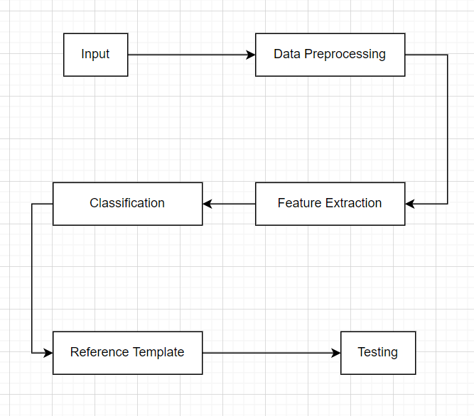

**Fig.No:-1**

**MODULES**

There are 5 models in our project:-

Data preprocessing

Feature extraction

Classification

Reference template

Testing

**1) Data Pre-processing:**

* Since our data is a video, we took a snapshot of it because the entire video is analyzed as frames and each frame is test data.

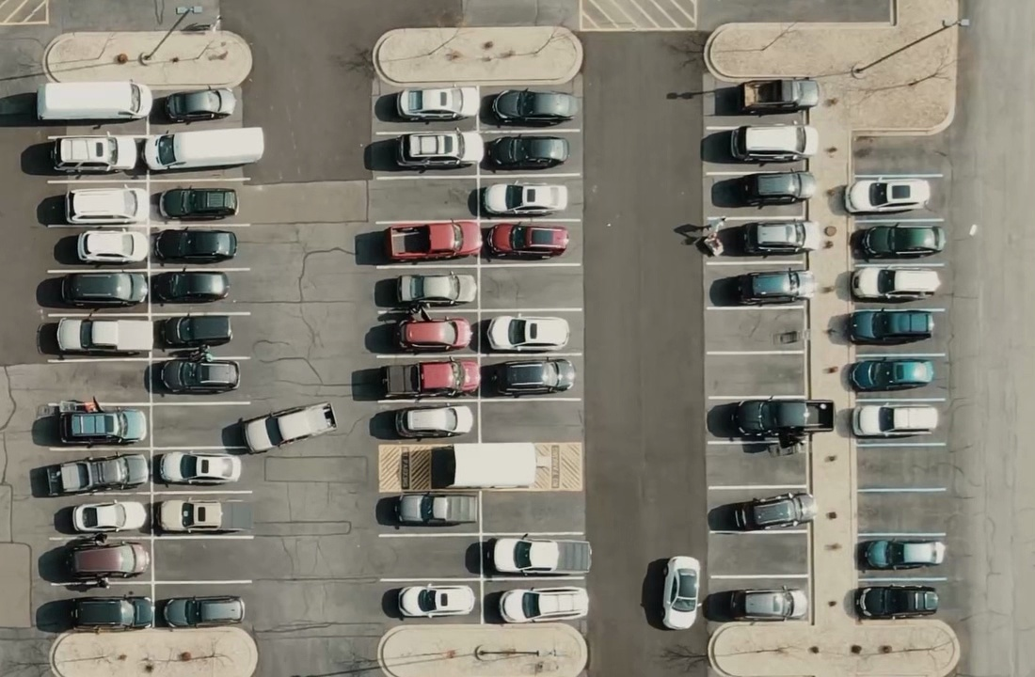

Fig.No:-2

* Here, after making a video of the whole frame, we try to find places where the car can park, because the existing models use a simple white line or any color line, which can be different in each situation, so if you arrange a box where the car should fit, it would help us to just analyze this part easily.
* Once we found all the parking lots for that video or location, we started making a box for the boundary of each parking lot using the pickle library in Python.

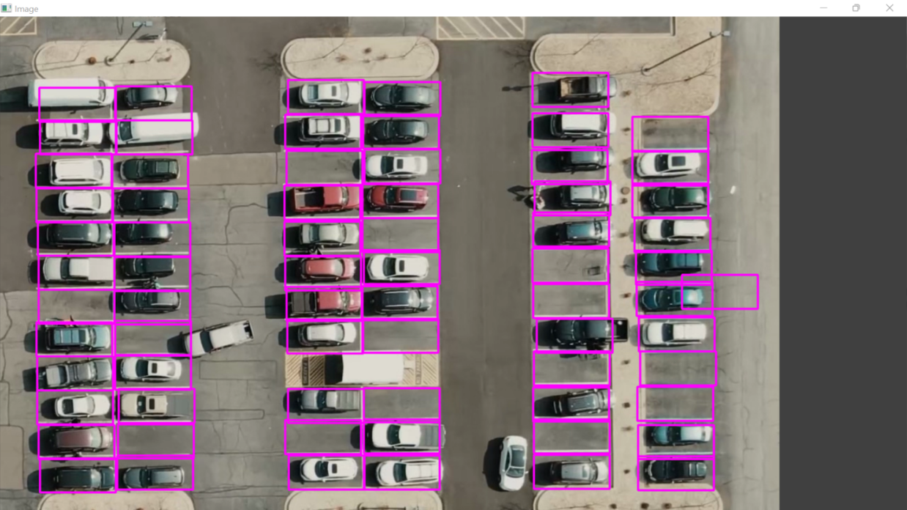

**Fig.No:-3**

**2) Feature Extraction:**

* Our main idea here is to get each box right because it is assumed that when a person is standing in a parking lot, they don't need to detect that there is a car and that it is parked. So it was quite a difficult task.
* For this process, we must first convert the image to grayscale.

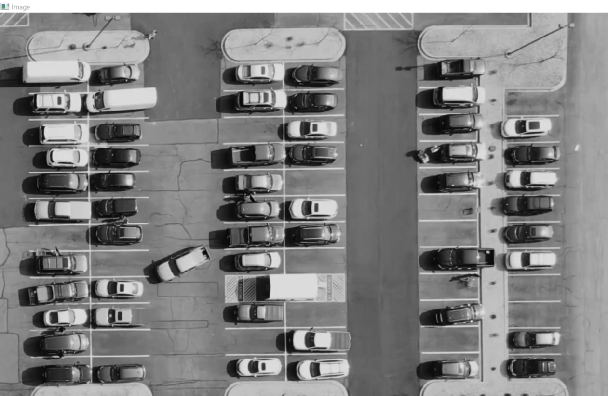

**Fig.No:-4**

* After some research, we discovered that converting an image from color to grayscale can result in increased noise levels, which can be caused by color differences at each location in the image. So we used Gaussian blur after converting to gray.

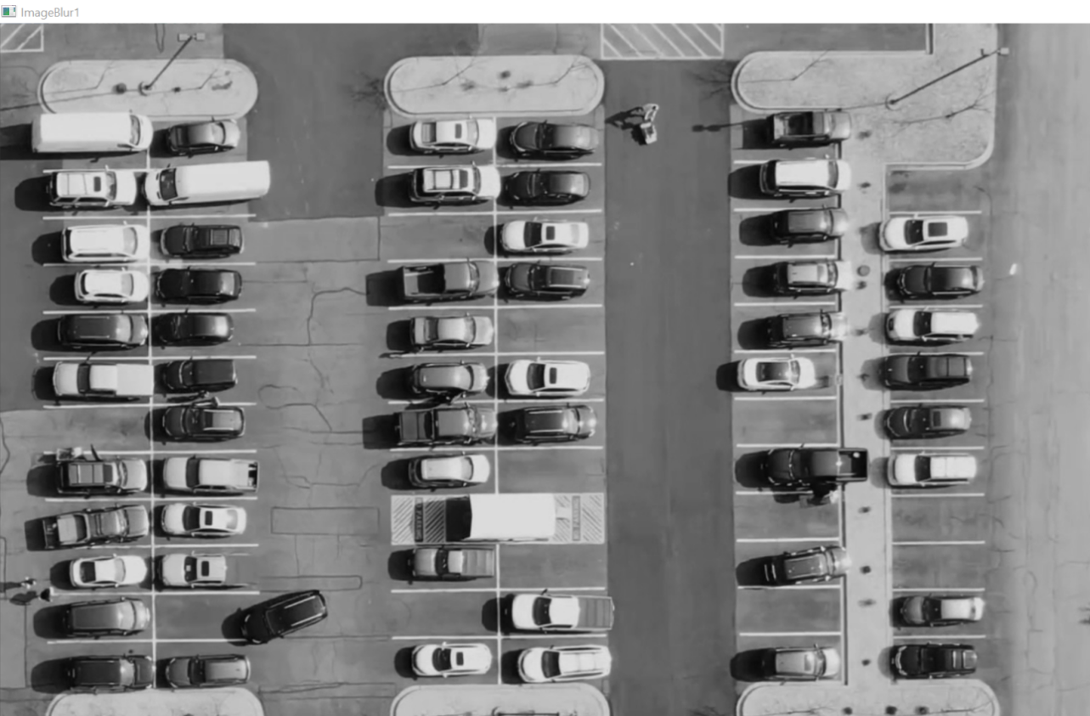

**Fig.No:-5**

* The process of blurring an image causes noise values to disappear or blend in with other pixel values. So we have a Gaussian blur of the vent.
* This is the core value that gives the final value according to the number of coordinates given in this function to make search decisions and remove noise values.

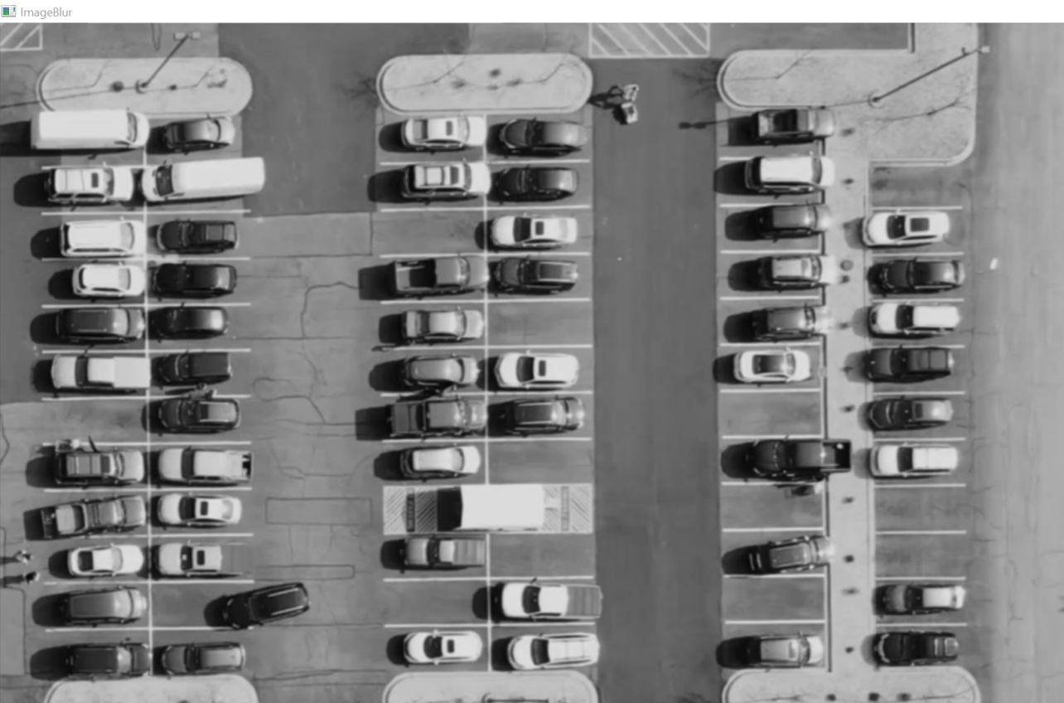

**Fig.No:-6**

**3) Classification:**

* Here, with some research, we found that we can get a good result from images if we make them black and white. The most important thing here is the contours of the image.
* The black color can be outside the edges of the image, and the white color is completely in the background, or vice versa. This can be done with the adaptiveThreshold function.

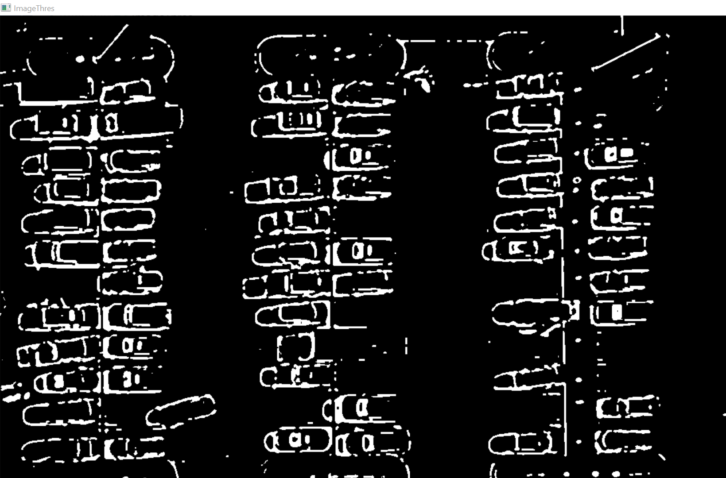

**Fig.No:-7**

After converting the image to black and white, we need to remove the noise points of the image using the kernel, and this information is set as a reference model.

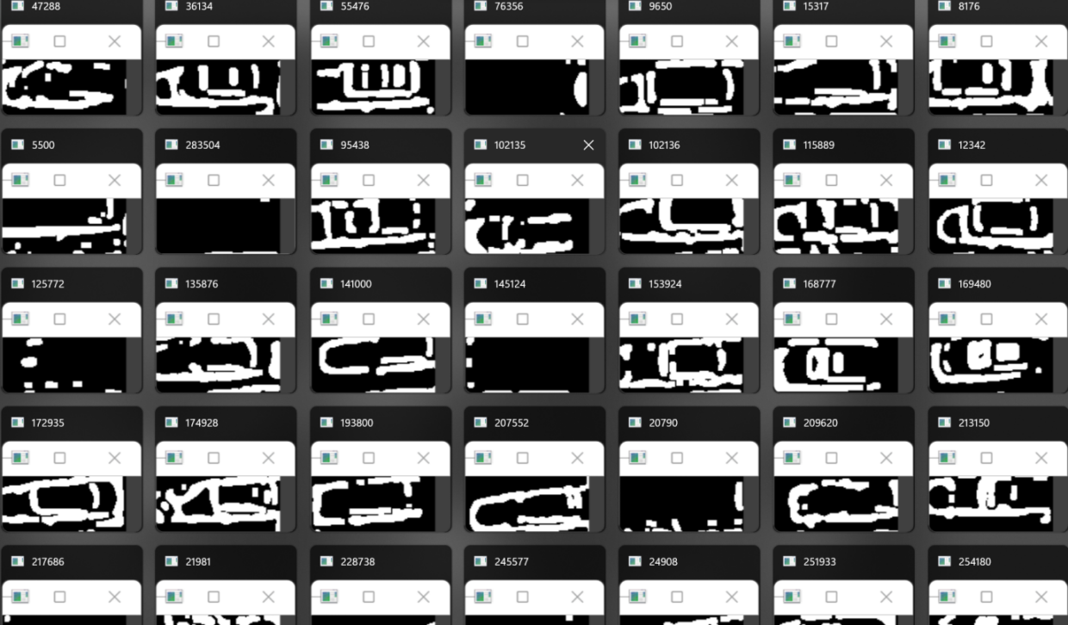

**Fig.No:-8**

**4) Reference Template:**

* After completing the machine learning part, we get the training data, which is called the reference model. It helps if the parking space to be analyzed takes more than 2 minutes (size of the training data), we can easily understand.
* To do this, we need to convert the input video to the full video that we wanted to analyze.

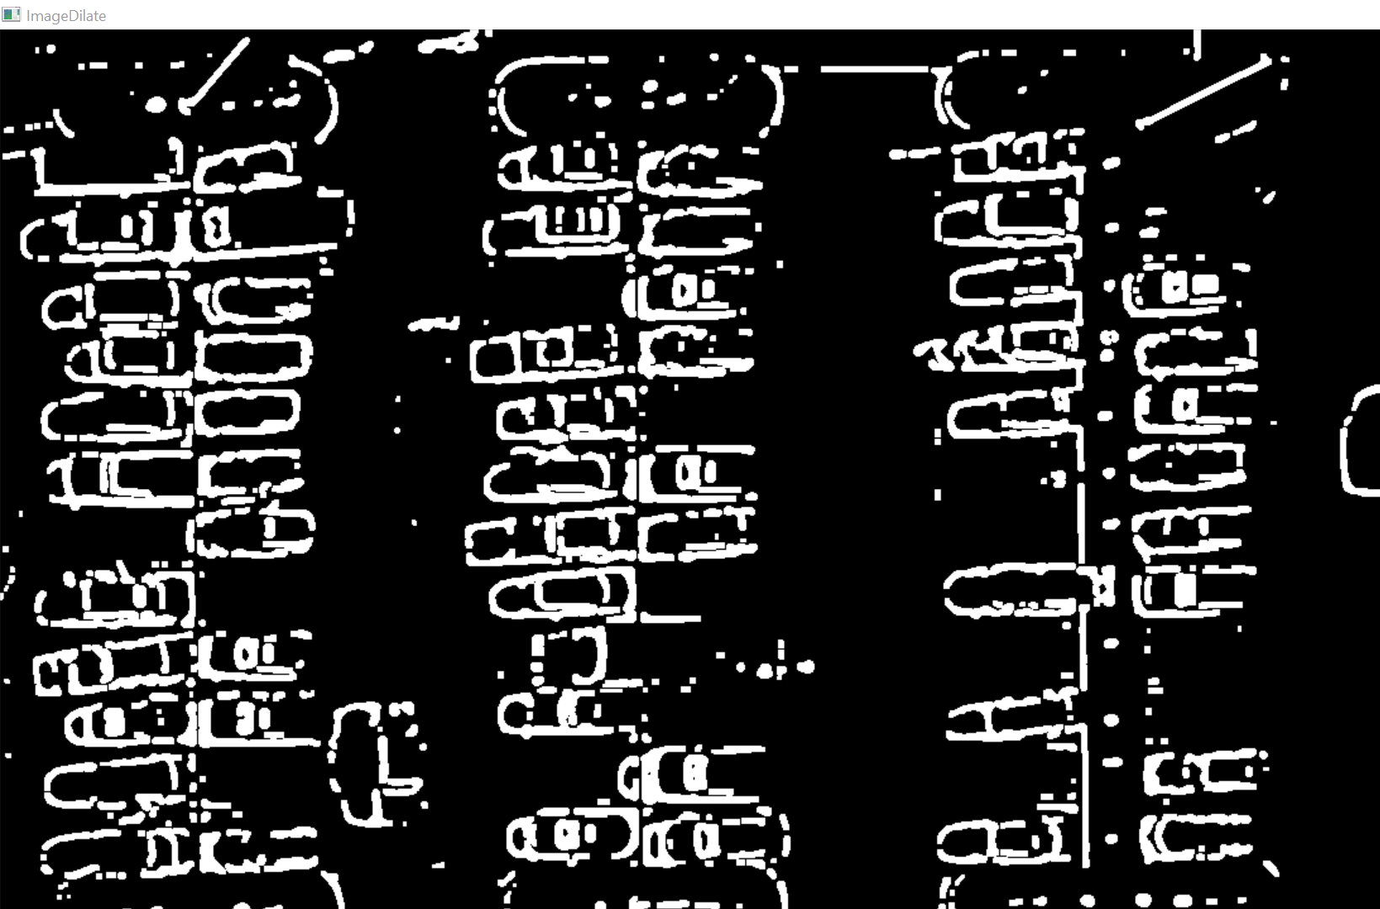

**Fig.No:-9**

**5) Testing:**

After the reference model is ready, we can test the data with test data, which means the real data that we want to analyse. 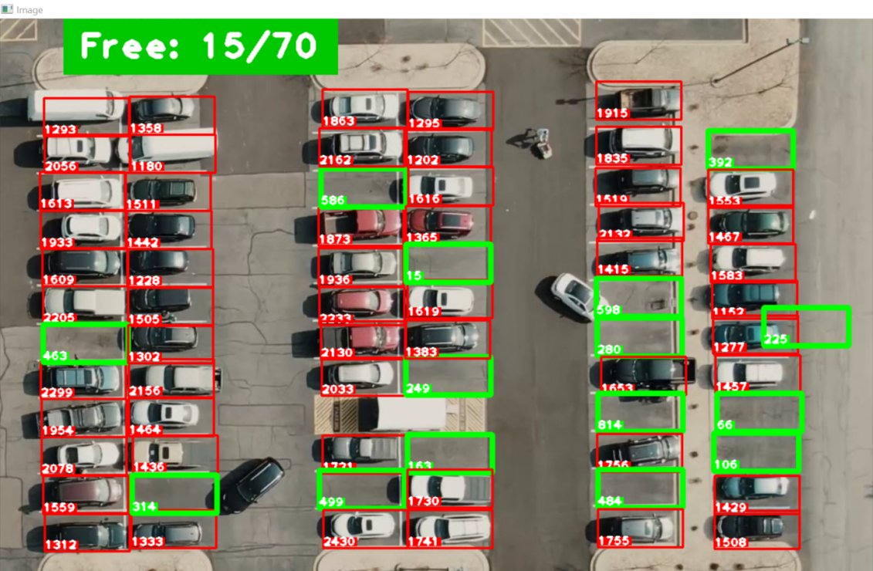

**Fig.No:-10**

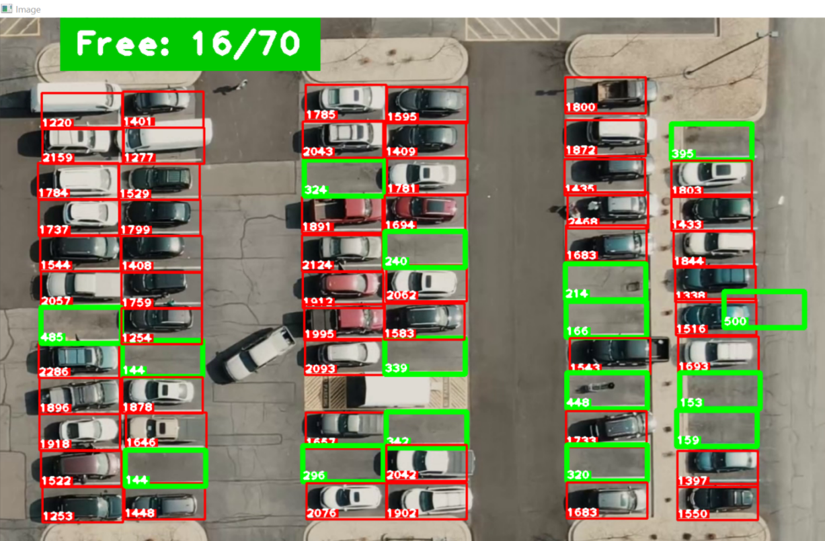

**Fig.No:-11**

**TECHNOLOGIES AND INTEGRATION**

The tools and programming languages used in this project are as follows:

**Python:** Python is a computer programming language that is often used to create websites and apps, automate tasks and analyze data. Python is a general-purpose language, which means that it can be used to create many different programs and is not specialized for specific problems.

**Cv2:** OpenCV is a huge open source library for computer vision, machine learning and image processing, and now it plays an important role in real-time operation, which is very important in today's systems. It can be used to process images and videos to identify human objects, faces or even handwriting.

**Pickle:** Pickle in Python is mainly used to serialize and deserialize Python object structure. In other words, it converts a Python object to a stream of bytes to store it in a file/database, save program state between sessions, or transfer data over a network.

**Cvzone**: This is a computer vision package that facilitates us, such as face recognition, hand tracking, pose estimation, etc., as well as image processing and other AI functions. It basically uses OpenCV and Media Pipe libraries.

**Numpy:** This is a very popular python library for large multidimensional matrices and matrix manipulation with a large number of advanced mathematical functions. It is very useful for basic scientific calculations in machine learning. We can convert various stored algorithms into functions that can be applied to arrays.

**IMPLEMENTATION DETAILS**

* In the implementation, we used Python image processing tools that help to give accurate results. Library cv2 helps to do all the image processing.
* First, as humans, we can easily recognize parking spaces by sight because we have experience. After detection, the best way to help the machine is to identify the parking space digitally, if the parking spaces are detected manually, it would be difficult because all the spaces are different and the information is confusing.
* So we use a pink box for detection and these boxes are selected with the mouse. After each box is detected, all the coordinates of the boxes are saved in a txt file.
* Then, on the next page, this file will open and each box will understand.
* This is only possible through image processing.
* Processing an image using machine learning modules is easy, but writing the right code yourself is easy. We will convert it to grayscale using some techniques and blur it to remove the noisy values. This data is then converted back to black and white and blurred again to remove more noise values and increase the limits to understand each car.
* After this process, we get a reference model that helps correctly find parking spaces from the test data.
* If there is a car in the parking lot, the box is highlighted in red, otherwise in green.

**RESULTS AND DISCUSSIONS**

* The main goal of our project was to create a way to help people not wait longer in the parking line.
* The dealer can easily add more parking spaces as it is user friendly. A new location must be selected and announced on the parking page, and the information will be properly stored and help with further processing.
* The detection of each parking lot is quite good. Each time period is detected and analyzed every second. This means that if the car is moving, it will say the car has left until half the car is out of the parking lot.
* No problem with human identification. If there is a person in the parking lot, the system does not detect it and shows it as a free shot.

**CONCLUSION AND FUTURE ENHANCEMENTS**

* As technology advances day by day, our lifestyle should grow. Many of them waste their time waiting for a parking space anywhere, and only a few places use a parking space due to an imperfect system.
* Our system does not analyze parking manually, but digital analysis helps the company identify easily and quickly. This reduces the waiting time for parking.
* Thanks to advances in machine learning and vision-based technology, cost-effective automated parking systems help drivers find available parking spaces.
* The improvement of this project can be that we can add if the car is correctly parked and we can link to the website where customers can choose a parking space in advance.

**REFERENCES**

* <https://link.springer.com/article/10.1007/s00138-008-0156-9>
* <https://www.researchgate.net/publication/301590571_OpenCV_for_Computer_Vision_Applications>
* <http://www.ijimt.org/papers/228-G0038.pdf>
* [https://www.researchgate.net/publication/320736588_Automatic_Parking_Space_Detection_System#:~:text=In%20this%20paper%2C%20a%20system,the%20images%20of%20the%20parking](https://www.researchgate.net/publication/320736588_Automatic_Parking_Space_Detection_System)
* [https://www.researchgate.net/publication/326439400_A_Smart_Image_Processing-based_System_for_Parking_Space_Vacancy_Management#:~:text=An%20image%20processing%20algorithm%20is,spots%20are%20occupied%20or%20otherwise](https://www.researchgate.net/publication/326439400_A_Smart_Image_Processing-based_System_for_Parking_Space_Vacancy_Management)

**SAMPLE CODE**

<https://drive.google.com/drive/folders/1KvVJ8YgX23lTaZaYL5dmZ9p84m0UsoTE?usp=sharing>

***THE END***